Date: February 27, 2017
Time: 6:30 – 8:00
Attendees
Chai Changsungsan | Howard Turner | Jerry Knotts | Reza Firoozabadi
Chuck Seabury | Doug Askegard | Mirwais Azizi | Stephanie Knotts
Cristian Cismaru | Gary Hughes | Nathalie Gosset | Viswa Prapurna Ramireddy
Deron Johnson

Calendar of Section events

Minutes from Previous Meeting
Minutes were accepted
IEEE R6 OPCOM Honorees

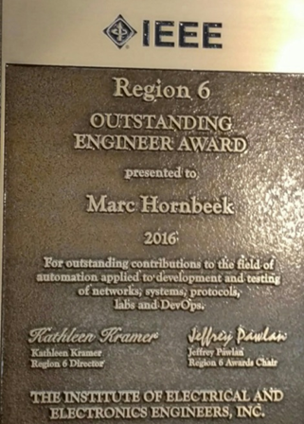 | 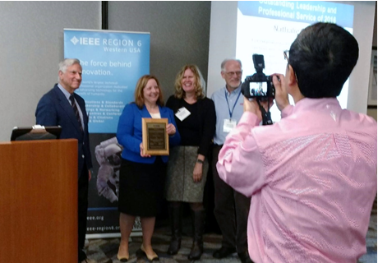
Marc Hornbeek | Nathalie Gosset, Outstanding Leadership and Service

February 23: NEWC Banquet – STEAM event at MATES
- The IEEE Buenaventura Section pre-purchased two tables (or 20 seats). 18 people attended the banquet. Officers received 50% discount for up to two tickets. The program was excellent.
  - IEEE had approved to pay for up to 10 tickets for engineering students from Ventura County. We had no applicants , we’ll try to figure out how to recruit some for next year
- 2 members supported the STEAM event at the elementary school
  - Students got to play with “Snap Circuits”
  - It was a busy night there
- Chuck mentioned that at a Discovery center there is a similar event
  - Maybe we can participate
  - Chuck will get more information
Upcoming Section Events
- Sr. Member Elevation Clinic
  - March 25th – Reza will get the process going.
- Spring Mixer
  - Moved earlier to April 3
Entrepreneurship Program
- Jerry, Darrell and Bridge discussed changing the meetings from a lecture format to having more audience participation
- Events will be like Mixers but focused on entrepreneurship for engineers.
  - There will be a facilitator and then audience discussions
- Next one is on 3/7
Photonics Speaker for March
- The Photonics speaker has not received approval to present his talk.
- The venue will be used instead by a floating event organized by Dennis Horwitz from ASME and this will be a co-host event with IEEE.
College and Pre-College Activities
- Mirwais Azizi is Director of digital learning at CLU and the Chair of IEEE BV College activities. Mirwais would like to introduce a new technology, called Lightboard that involves a glass chalkboard adapted for recording video lectures to facilitate long distance learning. The instructor faces toward the viewers, and the writing made on the board glows in front of presenter. This form of teaching would be more efficient to teach scientific materials.
- There is an opportunity with IEEE to solicit some grant funding to use technology to enhance the education in STEM of underserved populations. We discussed what the IEEE BV mission could be to partner with Mirwais Azizi to explore the potential of this new technology.
    - Hispanic students in Ventura County
    - Help with ADA compliance
    - Engage young people to inspire them to pursue STEM subjects
    - Working students that cannot easily get to campus
- Would facilitate high quality classes, on line collaboration with local and international students
- There is space at CLU dedicated to making a studio and lab for instructors
- Link to the site describing the technology discussed in the meeting – https://sites.google.com/site/northwesternlightboard/
- We went over what the system is and why it enhances learning
  - Mirwais will supply estimates for cost of the system and to soundproof the room
  - Nathalie will draft the proposal. Stephanie, Gary, Mirwais, and Viswa accepted to review the grant application.
Discussion of the IEEE Foundation grant awarded to BV Section for 2017
- The BV Section has been granted $18,000 to develop a project called “Aging Graciously with Technology.” The Section is still awaiting the funds. The project will have to be completed by Dec 31, 2017.
More news
- Region 6 meeting at Call Poly Pomona is on April 22
  - Here is the link for anyone that wants to attend ((https://www.eventbrite.com/e/region-6-joint-southern-and-southwestern-area-meeting-tickets-32224613687)
- Boxes of goodies to give out were given to chapters

Next Meeting: 3/27/17
- Entrepreneurship, Prof. Dev activities

