IEEE Buenaventura Section

OpCom Meeting Minutes

# November 28, 2016

|  |
| --- |
| Simi Valley, CA |

## Attendees

Doug Askegard

Tom Campbell

Cristian Cismaru

Darrell Gooden

Nathalie Gosset

Deron Johnson

Jerry Knotts

David Pehlke

Bob Rumer

Chuck Seabury

Howard Turner

The meeting was called to order at 6:45 PM.

## Minutes from Previous Meeting

Minutes from the October 24 meeting were accepted as submitted.

## Review of Budget and Expenses

Sana Sarfraz was not available for this meeting. Nathalie presented the Treasurer's report and section actuals in her absence, and they were accepted as submitted.

## Section Updates

David discussed a possible 5G summit, possibly just after the RAN4 standards meeting in April. He would be looking for help with organization ahead of time. For now, he is just giving us a heads-up.

The next OpCom meeting is scheduled for December 12. Nathalie suggested we might skip it if there is no pressing business, or perhaps do it by conference call.

Deron discussed the recommendations of the nominating committee.

* Howard Turner has agreed to be the Section Secretary.
* As reported last time, Sana Sarfraz has agreed to stay on as Treasurer for another year.
* No one has yet been found that is willing to take the role as Section Chair or Vice Chair. Nathalie Gosset has agreed to stay on as Section Chair for ~6 months until we find a new person.

Moved by David, seconded by Bob, to accept the recommendations. **Approved** unanimously.

Nathalie brought of the idea of hiring someone who could deal with the logistics of refreshments, pizza ordering, etc. For ~50 meetings per year this would work out to about 100 hours of labor, which would cost $2000 to $3000. Moved by Jerry, seconded by Darrell, that Nathalie should continue to investigate. **Approved** unanimously.

Nathalie walked us through the proposed financials for 2017, and requested feedback. A summary is below.

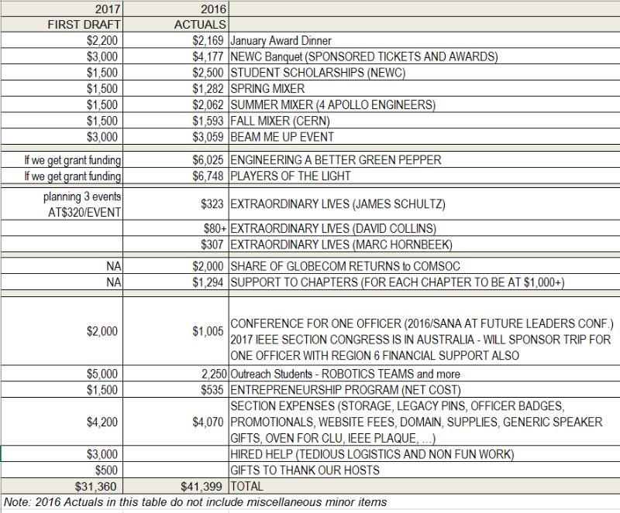

Meeting was adjourned at 8:30 PM.

## Next Meeting

|  |  |
| --- | --- |
| Date/Time | (Tentative) December 12, 2016, 6:30 PM |
| Location | Home of Nathalie Gosset and Doug Askegard, Simi Valley |