Date: September 25, 2017
Time: 6:30 - 8:00
Attendees
Bob Rumer | Deron Johnson | Howard Turner | Sana Sarfraz
Chai Changsungsan | Dhruv Roy | Jerry Knotts | Stephanie Knotts
Chuck Seabury |  | Lyman Hays | Tom Campbell
 |  | Nathalie Gosset | Viswa Ramireddy

Calendar of Section events
http://www.ieee-bv.org/conferences-and-events/ - monthly
CLU Rooms Reservation Q4
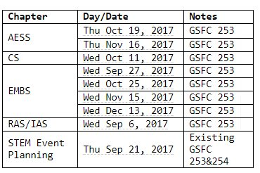

Minutes from Previous Meeting
Minutes were accepted
Financials
- Rooms for fall events are not yet in the budget. They will be added soon

Hub 101 Gift
- There was a request for a gift to Hub 101 to purchase a 3D printer
- Jerry made a motion that was passed to fund the gift.
- The gift is more costly than the usual gifts from the section.
  - A plan was made how to fund the gits
- CLU will purchase and maintain the printer
- The printer will be made available to the section when needed
Meeting with IEEE Foundation Member Karen Galuchie
- Nathalie, Deron and Howard will have dinner with her on Tuesday
- Some topics were suggested for discussion
  - Any other ideas for where to get money?
  - Can we get money from Life Members too?
  - Ask about a way to get some money in 2018. We missed the app deadline
GIRLS MAKE TECH WITH – October 7
- Some statistics
  - 120 Girls signed up and the wait list is full at 20
  - 99 parents
  - 30 volunteers
  - 8 or 9 workshops
- Parents will get a taste of all the activities along with the presentations
  - Need 2 more mentors for the parents
  - Parents will bring robots to lunch to demo to the girls
- Various members will build the Helping hands robots and get them to Lyman ASAP, definitely a few days before the event
  - The goal is to teach the girls about things like motors, gears, RPMs, electricity instead of having them spend the whole time building the robots
  - Lyman will take them partially apart to support teaching the concepts
  - Kits have been distributed along with a good screwdriver that Lyman has tested
  - This is awesome!
- Some of the materials will be used next year to extend the concepts
  - Example, use coding skills to make the robots and Arms smarter
  - Other ideas will come over the year
- Need laptops for the Arduino workshops
  - People volunteered to bring them
  - Deron also mentioned that people can donate laptops and get a receipt for them

First Lego Robotics Tournament
- Bob has been running the tournament
  - 4-6 grades
  - At La Reina
- He requested that IEEE take a more active role, the first step is to have 2 people shadow him at the event on November, 19 all day
- Deron volunteered
- Bob will draft a text that Ali to send email to the Robotics chapter
  - Deron will also forward it with the Computer chapter
2018 ExCom Officer Nominations
- Darrell, Stephanie and Wes (or Doug?) for are the committee
- We discussed succession for officers
- Some questions are how to make it more comfortable for people to accept officer positions

Next Meeting: 10/30/17

