Date: September 30, 2019
Time: 6:30 - 8:30

Attendees
Sana Sarfraz | Stephanie Knotts | Chuck Seabury | Reza Firoozabadi
Darrell Gooden (phone) | Jerry Knotts | Reza Firoozabadi | Doug Askegard
Deron Johnson | Nathalie Gosset

Event Scheduling
http://www.ieee-bv.org/conferences-and-events/
Schedule | Chapter | Location | Contact
1st Tue of month | Entrepreneurship | Hub101 | Doug A.
1st Wed of month | RAS/IAS | CLU | Viswa P.R.
2nd Tue of month | Communications | Skyworks | David P.
2nd Wed of month | Computer | La Reina | Deron J.
3rd Tue of month | Microwave | Skyworks | David P./Cristian C.
3rd Thu of month | Aerospace | CLU | Viswa P.R.
Last Mon of month | Section OpCom | Nathalie & Doug’s | -
Last Tue of month | ED/CAS | Skyworks | Cristian C.
Last Wed of month | EMBS | CLU | Viswa P.R.
Last Thu of month | Photonics | Hub101 | Doug A.

Calendar of Chapter Meetings
http://www.ieee-bv.org/chapter-events/

Minutes from Previous Meeting
Chuck Seabury moved to approve the August 2019 meeting minutes with no modification, Jerry Knotts seconded, all approved. Minutes were accepted.

September Highlights
- The Computer Chapter organized “Automotive Air/Fuel Management” a talk from Mark Bradley, that was very well received.
- The EMBS Chapter organized a talk with UCLA Dr. Mehmet Dokmeci who discussed “Microscale Sensors and Systems for Tissue Engineering and Regenerative Medicine Applications.”
- EDCAS attracted 59 attendees in a talk titled “5G and IoT or Internet of Threats” presented by Alan Way of HRL Laboratories.
- The MTTS Chapter organized an event. No detail known to attendees.

Nurturing the BV Section Recipe

The Oct 1st Entrepreneurship talk is cancelled.
  - Not able to secure a space for the talk. The Hub 101 space is full on Tues evenings for the Fall. The cancellation will be announced in the newsletter. We are also cancelling November ENT talk.
  - We reviewed how we can make things easier in the future.
  - Observations:
    - We are most successful in booking space with a several month notice.
    - Our hosts continue to be most welcoming to our events. They happen to have their own very busy evenings. With early notice, we usually can secure space for the date we need.
  - Recommendations:
    - Run a speaker planning session - typically scheduled once or twice a year, it is overdue. “This approach is part of what makes the BV Section successful” (Jerry).
    - A speaker planning session gives 1) a coordinated plan between chapters and section 2) long term visibility and 3) the opportunity to secure facilities over multiple months and plan announcements far in advance.
  - Action item:
    - Nov 18 - additional OPCOM meeting for a Speaker Planning session. Same place and same time as other OPCOMs.

Mon Oct 28: October OPCOM – focus vision 2020
NEW - Nov 18: Speaker Planning Session
Nov 25: November OPCOM – budget review and approval – final meeting for 2019

Financial Report (Treasurer)

Deron prepared the monthly financial report. The Section and the Chapters show healthy balances.
- The Aerospace Chapter received $300 from the Aerospace Society, an added support beyond the IEEE annual rebate.
- STEM Supplies for the upcoming Girls Make STEM with Heart is currently forecasted to be around $2,500 and catering $2,200 for food/drinks.
Motion to approve the treasurer’s report was presented by Jerry, seconded by Steph with all approving.

Professional Development

The Section is the recipient of the Educational Activities Board Award for Section Professional Development.

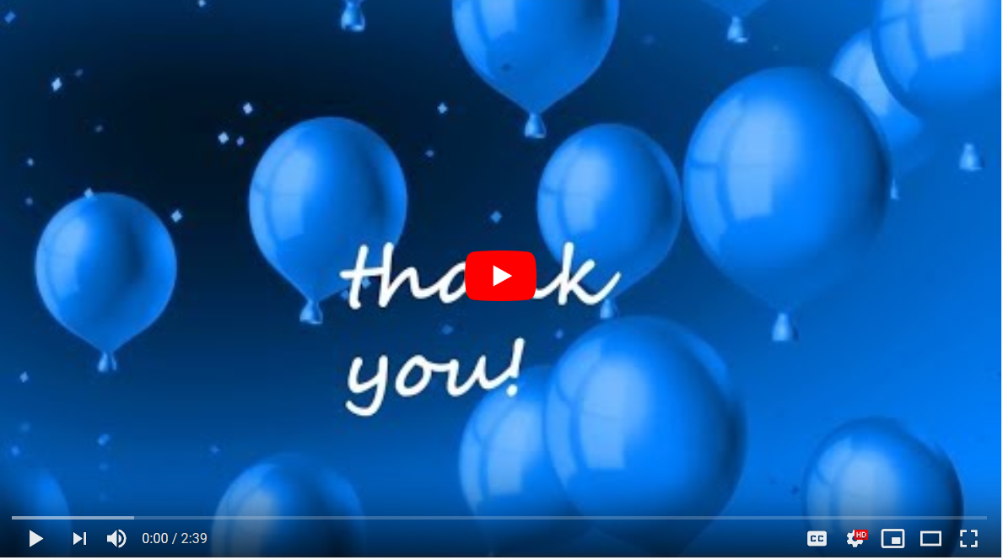

- Nathalie created this video , an item requested with the post-award package submitted to the EAB. This is a 2-minute summary with testimonies from some of the OPCOM officers, and a narration from Doug describing the Engineer to Entrepreneur Program and the Aging Graciously with Technology initiative. The video is a big thank you from the BV Section to the EAB, the IEEE Foundation, and the LMAG National. Deron uploaded the video on YouTube to enable The IEEE Foundation to place it on their website. The video is also active on our FB page.

- The EAB plans to recognize representation from the BV Section at a special award ceremony on Nov 22 in Boston, MA. A motion was passed last September for the Section to support the travel expenses with an undefined amount. Sana called for volunteers to attend. Darrell, Doug, and Nathalie volunteered.

- Sana is grateful for the interest of the volunteers. She cleared some points of confusion. The traveler is not being asked to pay for their trip. This type of motion is unfamiliar to her, she is uncertain about available funds, hence her current hesitation.

--> Action: Nathalie sent the process recommended to follow up on the approved motion. This is a tool that involves the Section Chair and the EXCOM team to develop the options around “how can we make this happen.”

Nathalie also gave some perspective of precedence.
  - The Section has historically been proactive in setting financial reserves to enable officers to represent BV at IEEE events when the events are known in advance.
    - Examples: The BV section enabled officers to represent BV at the IEEE Leadership Conference in New Orleans (1 officer), IEEE Raising Stars in Las Vegas (3), IEEE Section Congress in Australia (1), Section Congress in Quebec (3) and more.

  - The Section and chapters have also used the recommended process to manage surprise recognition awards. For example: EMBS award ceremony in France (4 officers), in Canada (4), in China (2), LMAG award in Phoenix (2) and more.

Action item: Sana will follow through the motion, work with the EXCOM using the process sent by Nathalie and scope possible pathways.

Membership Development

- Sana’s application to create a WIE was declined by WIE.

- LMAG: Jerry reported that the LMAG team is developing a new initiative that aims to be launched in Mid-March and would attract a broader range of LMAG members and possibly attract new members. The LMAG National $2K grant may align nicely with this iniative.

Girls Make STEM with Heart on Oct 19

- 145 girls middle-school age and 125 parents registered for the event. The event also counts between 25 and 30 mentors for the workshops. The registered children study in various public schools in Ventura County.
- The event is sold out. We also have:
1) an additional 20 girls on the waiting list,
2) an additional registration site for girls from La Reina High School and Middle School, the institution graciously hosting of the event - max capacity of 20.

- Historically, we have had an average 30% of no-show to our Girls Make STEM with Heart. Darrell confirms this statistic from his experience with VCOE events. We discussed how to reach and manage at optimal capacity (~ 140 kids, 120 parents).
- Perhaps letting the girls and family on the waiting list know that they are accepted in the event (Darrell’s recommendation)
- We keep the site is that is sold out closed – out of fairness for the waiting list and the families who tried and could no longer join. (Nathalie)
- We keep the La Reina registration site open till it fills up to 20. (La Reina has not advertised the event in their school newsletter yet).
- Assume that 30% will be no-show.

- The caterer will be Buca (pasta and salads). Headcount will be adjusted closer to the event.

- Sana ordered 250 RFID blocking card holders as giveaways.

Fall Mixer Planning (event Nov 7)

- Reza will manage the planning of the Fall expert panel event, the annual closing event for the Section. Reza will use the same process as last year, with solicitation of topic ideas from the officers.
- Action item: Reza will reach out to the officers to collect suggestions of topics.

Nominations for Section Officers
- Sana requested a 150-word biography from Deron, Steph, and Howard as part of their candidature for the position of Chair, Vice Chair, and Secretary.

- A nomination call is queued to go to the BV members with the October 2019 newsletter.

Planning the Section Vision for 2020
The meeting ran out of time. This topic will be added to the Oct 28 OPCOM agenda.

Next Meeting: October 18

