Date: September 28, 2020
Time: 6:30 - 8:30

Attendees

Bob Rumer
Cristian Cismaru | Jerry Knotts | Reza Firoozabadi
 | Karl Geiger | S.K. Ramesh
Deron Johnson |  | Stephanie Knotts
Doug Askegard | Momin Quddus

*by phone

Event Scheduling
http://www.ieee-bv.org/conferences-and-events/
Schedule | Chapter | Location | Contact
1st Tue of month | Entrepreneurship | Hub101 | Doug A.
1st Wed of month | RAS/IAS | CLU
2nd Tue of month | Communications | Skyworks | Mohammad T.
2nd Wed of month | Computer | La Reina | Deron J.
3rd Tue of month | Microwave | Skyworks | Momin Q
3rd Thu of month | Aerospace | Hub101 | Doug A.
Last Mon of month | Section OpCom | Nathalie & Doug’s | -
Last Tue of month | ED/CAS | Skyworks | Cristian C.
Last Wed of month | EMBS | La Reina | Bob R.
Last Thu of month | Photonics | Hub101 | Doug A.

Calendar of Chapter Meetings
http://www.ieee-bv.org/chapter-events/

Minutes from Previous Meeting
- Accepted with no changes

Check in with Everyone
- All still healthy

Current Highlights

- MTTS – 14 attendees, a few new people
  - An Engineer’s Introduction to Lightweight Backpacking
  - Link to the slides are on the web site and in the latest newsletter
  - Some people had a problem joining the meeting
    - Case 690038837 opened with IEEE WebEx support
    - So far, I’m getting a standard support run around, I’ll push for a while and see if I can get more information.
- EMBS
  - Model Based signal Processing in Critical Care
    - Using non-invasive methods to measure brain waves
  - Speaker was from MIT
  - Collaboration with Alberta Section
- ED/CAS
- Entrepreneurship
- AESS
- COMPUTER SOCIETY

Membership Development
- Our Section received an award for meeting our goals for retaining members
- 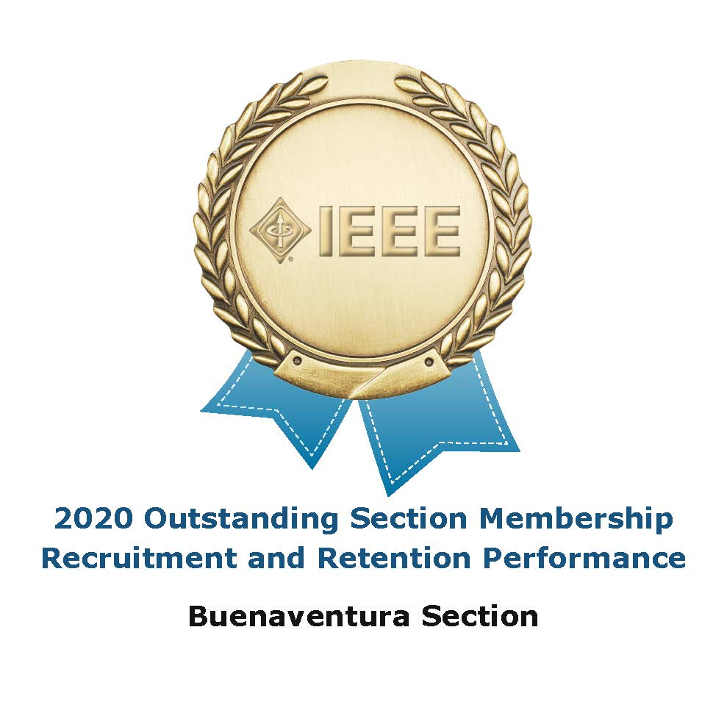
Treasurer’s Report
- Circuits and Systems Society (CASS) money was received and credited to the ED/CAS joint chapter account
- Final payment for the 2018 IEEE Foundation grant “Ageing Securely with Technology” project received and credited to the Section’s account
- Expenses
  - Storage - $100
  - Small expenses for some equipment purchased for instructors working on the “Girls Make Tech With Heart” program. See below.
- Please sign up for IEEE Google suite tools
  - Log onto your IEEE account and set up your IEEE.ORG identity; see https://www.ieee.org/membership/connection.html
  - This will allow you to see all the accounting info on-line
  - Link to the Section Google drive folders
  - Deron will put together a short document about how to access files in Google Drive. It can be a bit confusing since you need to be logged in with the correct account.
  - Monthly reports will still be available at the OpCom meeting.
    - Chapter Budget Tracking Spreadsheet
    - Section Budget Tracking Spreadsheet
    - 2020 Sustainability Project Budget Tracking Spreadsheet

Sections Congress – Deron – You may need to select enroll
- Slides and Conference Recordings
- Of particular interest: How to be Successful in a Virtual Environment
- Recommendations
  - Create a 3-5 years membership with discounts compared to yearly membership
  - Provide continuing education
  - Provide resources to Sections to serve industry professionals and engage with local industries

IEEE Foundation Grant

- Deadline for spending funds has been extended until the end of 2021.

Upcoming Chapter Meetings
- EMBS – October 22m 2020 @ 5 PM
  - Artificial Intelligence Applications to Modern Cancer Surveillance
  - Speaker – Georgina Tourassi from Duke
- MTTS – October 14, 2020
  - Automotive Radar – A Signal Processing Perspective on Current Technology and future Systems
  - Speaker – Markus Gardill

Section Event Planning
- For upcoming local events, chapters can use WebEx if they would like, or any remote access platform they have access to
  - There is a BV Section IEEE WebEx account
  - Contact Deron or Howard for information how to use it
  - It is only for IEEE business
- STEM Projects and Fall “Girls Make Tech with Heart” Event
  - Workshops - Deron
  - Karl created some STEM playlists on the Section’s YouTube Channel. These feature compilations of existing videos:
    - STEM – Rockets!
    - STEM – DIY Robots!
    - STEM – Home Electricity
    - STEM – Magnets
    - Karl asked for more playlist ideas. Ramesh suggested looking at the “Try Engineering” program. More suggestions welcome.
  - GMTwH Workshop development is ongoing, maybe slowed by not having a hard deadline
  - Microbit Step by Step is in good shape
    - Kit has a microprocessor, cables and can blink LEDs
    - Can be drop shipped from Amazon
    - $20.21 including tax and shipping
  - Another workshop planned.
- Mixers – Tentative dates
  - Fall –
    - Suggestion from Howard, can we do a virtual event?
    - Come up with a fun format and let people hang out online
- Senior Elevation – Question from HT, can this be done online?
  - There was a consensus among the officers to reschedule the event
  - A big value is having in-person meetings with the nominees

Officer Development
- Entrepreneurship
  - Darrell is busy with his new job and had to resign from OpCom and planning
- Section Chair
  - Deron requests someone replace him for 2021

IEEE Awards
- There are 15 awards that can be given by the region
  - Someone can nominate people
    - Doug has forms
  - There are a few categories that someone from our area can be nominated for

Updated local documents
- Scheduling a Meeting in Eventbrite
- Public Meeting Setup
  - This is specific to the Computer Chapter, but feel free to use it as a starting point
- Using Google Drive with Multiple Accounts (in progress)
- Send feedback to Deron

Meeting reports Reminder
- It is up to chapters to submit their “L31” meeting reports
  - Going forward, the treasurer will not check if a meeting report has been submitted before issuing a reimbursement.

Next Meeting: October 26
Focus topic: Budget for 2021, this will be a unique budget cycle

