Date: October 26, 2020
Time: 6:30 - 8:30

Attendees

 | Jerry Knotts
 | Karl Geiger | S.K. Ramesh
Deron Johnson | Mohammad Tehrani | Stephanie Knotts
Doug Askegard | Momin Quddus
Howard Turner

*by phone

Event Scheduling
http://www.ieee-bv.org/conferences-and-events/
Schedule | Chapter | Location | Contact
1st Tue of month | Entrepreneurship | Hub101 | Doug A.
1st Wed of month | RAS/IAS | CLU
2nd Tue of month | Communications | Skyworks
2nd Wed of month | Computer | La Reina | Deron J.
3rd Tue of month | Microwave | Skyworks | Momin Q
3rd Thu of month | Aerospace | Hub101 | Mohammad T.
Last Mon of month | Section OpCom | Nathalie & Doug’s | -
Last Tue of month | ED/CAS | Skyworks | Cristian C.
Last Wed of month | EMBS | La Reina | Bob R.
Last Thu of month | Photonics | Hub101 | Doug A.

Calendar of Chapter Meetings
http://www.ieee-bv.org/chapter-events/

Minutes from Previous Meeting
- Accepted with no changes

Check in with Everyone
- All still healthy

Current Highlights
- MTTS – October 14, 2020
  - 18 attendees
  - Automotive Radar – A Signal Processing Perspective on Current Technology and future Systems
  - Speaker – Markus Gardill
  - Slides and PowerPoint have been posted
  - Issue with logging onto a meeting
    - Case 690038837 opened with IEEE WebEx support
    - Closed the case, the support people wanted information that could not be provided
    - Apparently, attendees can open a case themselves and provide info. Recommend the following at the end of meeting invites:
Can’t join the meeting? Troubleshooting • Contact support
- EMBS
  - Model Based signal Processing in Critical Care
    - Using non-invasive methods to measure brain waves
  - Speaker was from MIT
  - Collaboration with Southern Alberta Section
- ED/CAS
- Entrepreneurship
- AESS
- COMPUTER SOCIETY

Membership Development
- The Section received an award for meeting our goals for retaining members
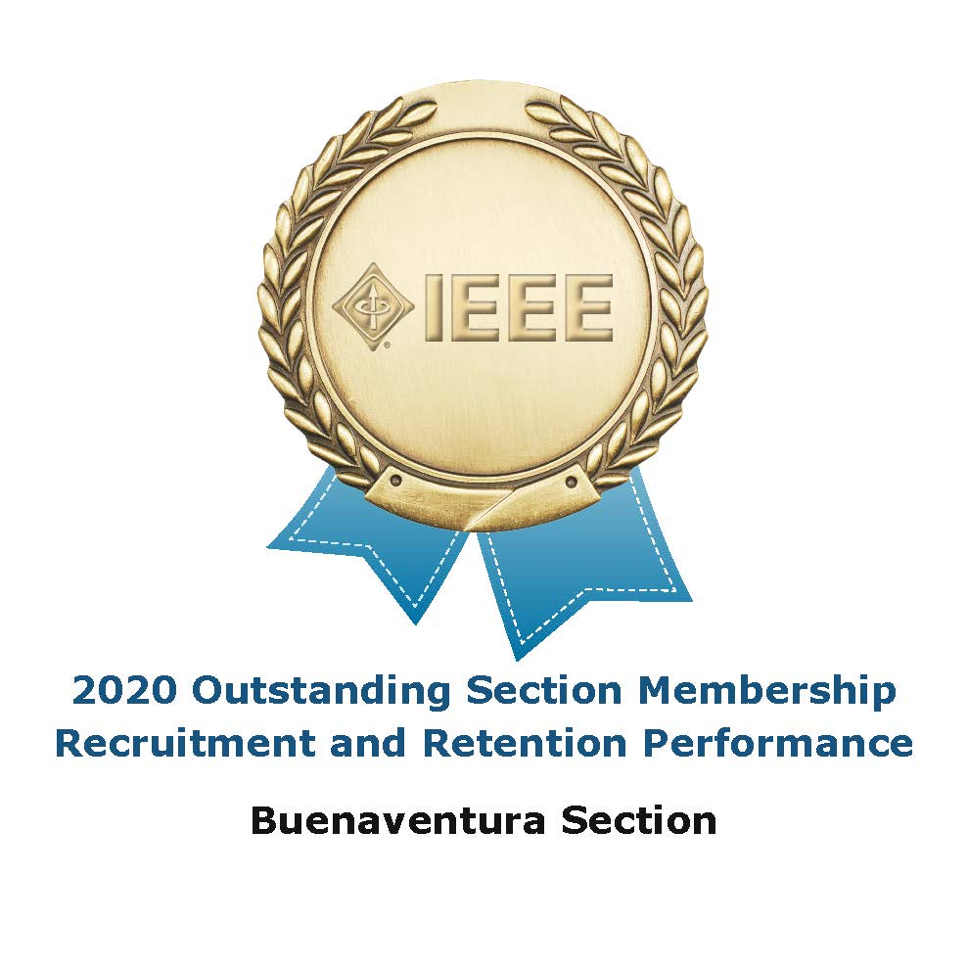
Treasurer’s Report
- Karl sent the report
- Expenses
  - Latest information is available in Google Docs
  - Storage - $100
  - Small amount spent to send a kit to plan for a Girls Make STEM with Heart workshop
- Please sign up for IEEE Google suite tools
  - Log onto your IEEE account and set up your IEEE.ORG identity; see https://www.ieee.org/membership/connection.html
  - This will allow you to see all the accounting info on-line
  - Link to the Section Google drive folders
  - Deron will put together a short document about how to access files in Google Drive. It can be a bit confusing since you need to be logged in with the correct account.
  - Monthly reports will still be available at the OpCom meeting.
    - Chapter Budget Tracking Spreadsheet
    - Section Budget Tracking Spreadsheet
    - 2020 Sustainability Project Budget Tracking Spreadsheet

Upcoming Chapter Meetings
- EMBS – 3rd week in November will have another meeting
- CS – 2nd week in November will have meeting to get member input

Section Activities
- For upcoming local events, chapters can use WebEx if they would like, or any remote access platform they have access to
  - There is a BV Section IEEE WebEx account
  - Contact Deron or Howard for information how to use it
  - It is only for IEEE business
- Fall – Mixer
  - Ramesh mentioned using a beta app called Hi Fidelity if it is decided to use it
  - Having a virtual mixer did not get much enthusiasm
- Senior Elevation
  - At the April OpCom the conversation was to wait to see if an in-person event becomes possible
  - Ramesh suggested that a virtual event is reasonable
  - Deron will speak with Reza

STEM Activities
- STEM Projects and Fall “Girls Make Tech with Heart” Event
  - bbc micro:bit Workshop – Deron
    - Steve Case has been writing code that can be used
    - Deron reached out to a school to do a beta run
      - Date is TBD, possible in January
  - Physics Kits- Mohammad
    - Deron and Mohammad will meet to discuss details and see if this makes sense
  - Karl created some STEM playlists on the Section’s YouTube Channel. These feature compilations of existing videos:
    - STEM – Rockets!
    - STEM – DIY Robots!
    - STEM – Home Electricity
    - STEM – Magnets
    - Karl asked for more playlist ideas. Ramesh suggested looking at the “Try Engineering” program. More suggestions welcome.

Officer Development
- Doug asked Deron if he has found a replacement for himself. Deron is working on it...

Other Business
- Doug mentioned that the list of chapter chairs is out of date
  - Robotics, Com/Soc and photonics have no leaders
  - Deron will get a list of RAS/IAS members to Doug, and a list of ComSoc members to Victor and Li
- Officer gifts
  - Deron will get Stephanie a list of addresses for people to receive the gifts

Updated local documents
- Scheduling a Meeting in Eventbrite (Somewhat out of date, since Eventbrite has moved everything around.)
- Public Meeting Setup
  - This is specific to the Computer Chapter, but feel free to use it as a starting point
- Using Google Drive with Multiple Accounts (in progress)
- Send feedback to Deron

Meeting reports Reminder
- It is up to chapters to submit their “L31” meeting reports
  - Going forward, the treasurer will not check if a meeting report has been submitted before issuing a reimbursement.

Next Meeting: November 30
Focus topic:

